CS264 Lab 7

1. phat1 = 0.344
phat2 = 40/75~0.533
SD=sqrt(phat1*(1-phat1)/75)

pnorm(phat2, mean=phat1, sd=SD, lower.tail=FALSE) => p-value = 0.0002785865
prop.test(40, 75, p=phat1, alt="greater") => p-value = 0.0004341

This does not seem to support the nationwide population because the p-value is very small.
The p-values are not exactly the same, but they are very similar.

2. H0 – Salary = 55000
HA – Salary > 55000

xbar = 58260
s = 3250
n = 25
SE=s/sqrt(n)
1-pt((xbar-55000)/SE, df=n-1) = 1.998964e-05

We accept the alternate hypothesis because the p-value is very low.

3.a. wilcox.test(data, mu=log(22), alt="greater") => p-value = 0.004144

The median pay is more than 220K, because the p-value is very low.

3.b. We are using log-transformed data because everything is closer together, making the it
more symmetrical.

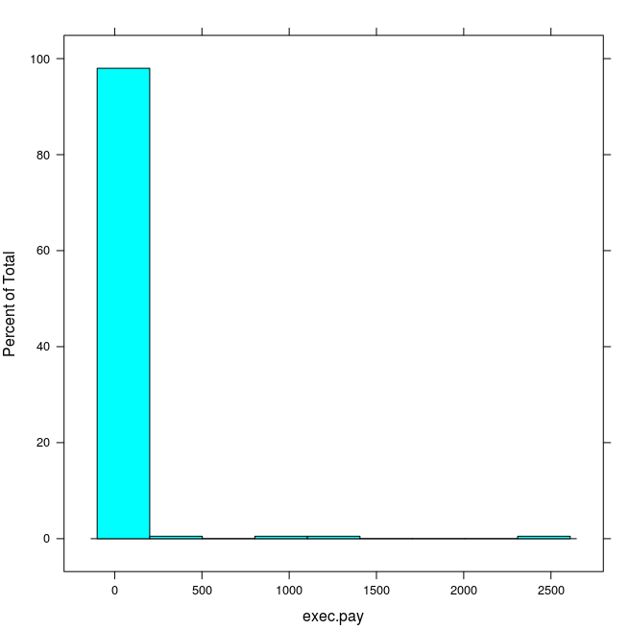
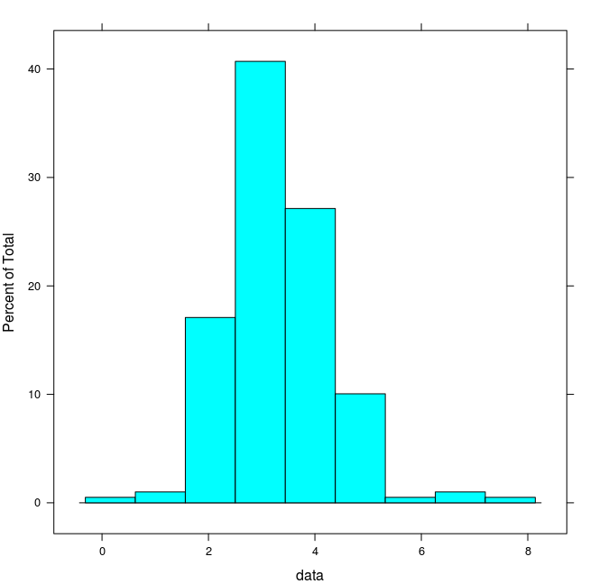

As we can see, the graph on the right is much easier to read.

4. phat = c(14/150,15/125)
n = c(150, 125)
prop.test(n*phat, n, alt="less") = p-value = 0.3016

The p-value is not small enough to show that brand A has a smaller chance of being returned than brand B.

5.a. plot(density(shoes$A))
lines(density(shoes$B), lty=2)

5.b. t.test(shoes$A, shoes$B, var.equal=TRUE) = 10.63, 11.04
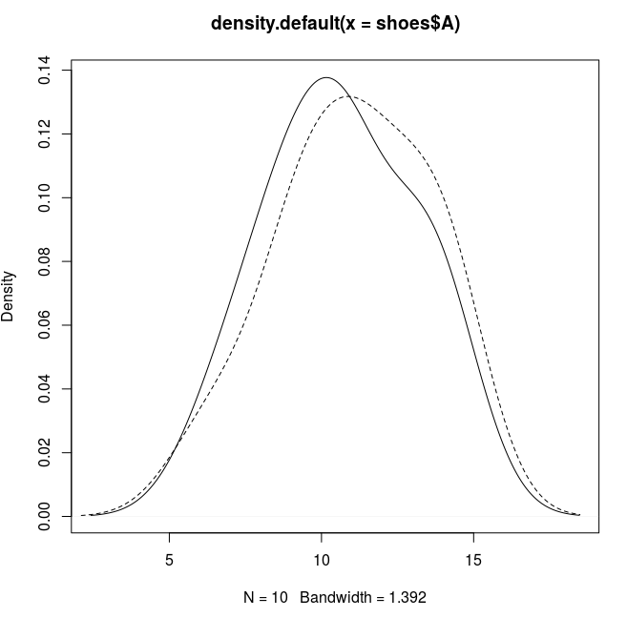

We assume equal variances because from the graphs we obtain, the distribution looks very similar between the two graphs.

